ARPY : Enhancing Novice Python Comprehension by Addressing Learning Difficulties through Design-Focused, Interactive Augmented Reality Visualization

Metha Anastasya   
*Department of Information Technology  
Faculty of Informatics, Telkom University Jakarta  
Jakarta, Indonesia*  
[methaanastasya@student.telkomuniversity.ac.id](mailto:methaanastasya@student.telkomuniversity.ac.id)

Aditya Ataby Hidayat   
*Department of Information Technology  
Faculty of Informatics, Telkom University Jakarta  
Jakarta, Indonesia*  
[dithdyt@student.telkomuniversity.ac.id](mailto:dithdyt@student.telkomuniversity.ac.id) Muhammad Rizky Hadi Prawiro   
*Department of Information Technology  
Faculty of Informatics, Telkom University Jakarta  
Jakarta, Indonesia*  
[rizkyhadi@student.telkomuniversity.ac.id](mailto:rizkyhadi@student.telkomuniversity.ac.id)

Indra Aulia   
*Department of Information Technology  
Faculty of Informatics, Telkom University Jakarta  
Jakarta, Indonesia*  
[indraaul@telkomuniversity.ac.id](mailto:indraaul@telkomuniversity.ac.id) Satrio Aji Nugroho   
*Department of Information Technology  
Faculty of Informatics, Telkom University Jakarta  
Jakarta, Indonesia*  
[strioaji@student.telkomuniversity.ac.id](mailto:strioaji@student.telkomuniversity.ac.id)

*Abstract*—The integration of Augmented Reality (AR) technology into education has the potential to revolutionize the way programming languages, such as Python, are taught. This research explores the development of ARPY (Augmented Reality Python), an AR-based application designed to enhance the learning of Python programming through interactive, visual, and user-centered learning experiences. Traditional programming education often struggles with conveying abstract concepts, such as data structures and branching logic, which can be difficult for students to grasp without contextual visualization. By employing the User-Centered Design (UCD) methodology, this study ensures the application meets user needs, creating an intuitive and engaging interface for learners. The ARPY prototype was developed using Vuforia for AR card recognition and Unity for tracking 3D objects. Qualitative data from interviews and surveys with students from SMK 1 Jakarta and Bina Sarana Informatika University informed the design and feature set of the application. Usability testing, conducted via the System Usability Scale (SUS), resulted in a score of 70.25, reflecting a positive user experience. The results indicate that the integration of AR and UCD principles significantly improves the understanding of complex programming concepts and enhances student engagement. This study provides valuable insights for the future of AR-based educational tools and suggests that further research should focus on scaling content complexity and evaluating the long-term effects of AR in programming education.

Keywords—Augmented Reality, User-Centered Design, Python Programming, Interactive Learning, Educational Technology

# Introduction

The development of information technology in the world of education is part of Industry 4.0, which has changed the paradigm of learning from text-based or lecture methods to a more creative and interactive approach through Augmented Reality (AR) technology [1]. Augmented Reality (AR) technology and interactive media enable visual integration in educational process, creating a more flexible and contextual learning space [2]. Understanding branching logic and data structures in programming languages such as Python is often a crucial challenge that hinders the learning process, especially when the material is presented textually without contextual visual support. This challenge is particularly experienced by students who are still developing a basic understanding of programming concepts and logical thinking [3]. Previous research shows that the use of AR significantly improves understanding of programming concepts such as branching logic and data structures by providing more interactive visualizations [4]. Augmented Reality can be a potential solution to improve the effectiveness of programming learning among students [5].

Augmented reality (AR) possesses considerable potential in of Python programming, as it facilitates the presentation of material in a manner that is both visually engaging and interactive. This phenomenon is not solely indicative of an increase in student participation, it also facilitates their comprehension of fundamental concepts in programming, which are often challenging to grasp through conventional methods [6], [7]. AR enables abstract concepts in a subject, such as data structures and algorithm flow, to be visualized in the form of 3D animations that can be seen and understood directly, thereby minimizing barriers to learning [8], [9]. To optimize the effectiveness of AR, the role of effective user interface design (UI/UX) is importance. The User-Centered Design (UCD) method prioritizes the needs and preferences of the users during the process of designing the user interface (UI) and user experience (UX), resulting in a more intuitive and accessible interface that enhances user comfort and efficiency [10]. The implementation of UCD in the design of AR provides an opportunity to actively involve students in the learning process and ensure that the resulting application meets their expectations. Therefore, the integration of AR and user interface/user experience (UI/UX) UCD in the Python educational application is expected to facilitate more engaging and effective learning experiences [11].

Previous studies have explored the use of Augmented Reality (AR) in computer programming education [6], [7]. In addition, the User-Centered Design (UCD) approach has been applied in user interface design [10], [11]. However, both of these approaches have been studied separately and have not been integrated within the context of Python programming language learning. This research integrates AR technology with user interface and user experience (UI/UX) design principles in programming Python learning, thereby fostering an interactive and user-centered learning experience [9]. The objective of this study is to develop an AR-based educational application prototype for Python programming language learning using a UCD approach. It is expected that this will result in the creation of an application that is not only interactive but also comfortable to use and meets user expectations. This will have a greater impact on the development of AR-based Python programming learning methods and enhance students understanding.

# RELATED WORKS

## Technology Transformation in Programming Education

Augmented reality (AR) represents a significant development in the field of programming education, particularly in the context of Python. It has been demonstrated in prior research that AR enhances comprehension of data structures and branching logic in the Python programming language [3]. However, the inability of AR to effectively handle more complex learning materials remains a significant challenge [6]. The implementation of AR applications in education has been limited to the introduction of simple objects [12]. this research integrates Python material into AR to offer interactive learning.

## The Implementation of User-Centered Design in Educational Applications

In addition to augmented reality (AR) technology, the design of user interfaces (UI) and the user experience (UX) design play a crucial role in creating effective and engaging educational applications [10]. The effectiveness of applications is ensured by the User-Centered Design (UCD) method, which ensures the interface is tailored to the needs and preferences of users [11]. However, previous studies have only partially applied UCD principles, without achieving deep integration between interface design and dynamic user interactions. This deficiency frequently manifests in applications that exhibit diminished adaptability to evolving user requirements [13]. A comprehensive implementation of UCD in the development of AR applications is anticipated to yield a more intuitive and personalized user experience.

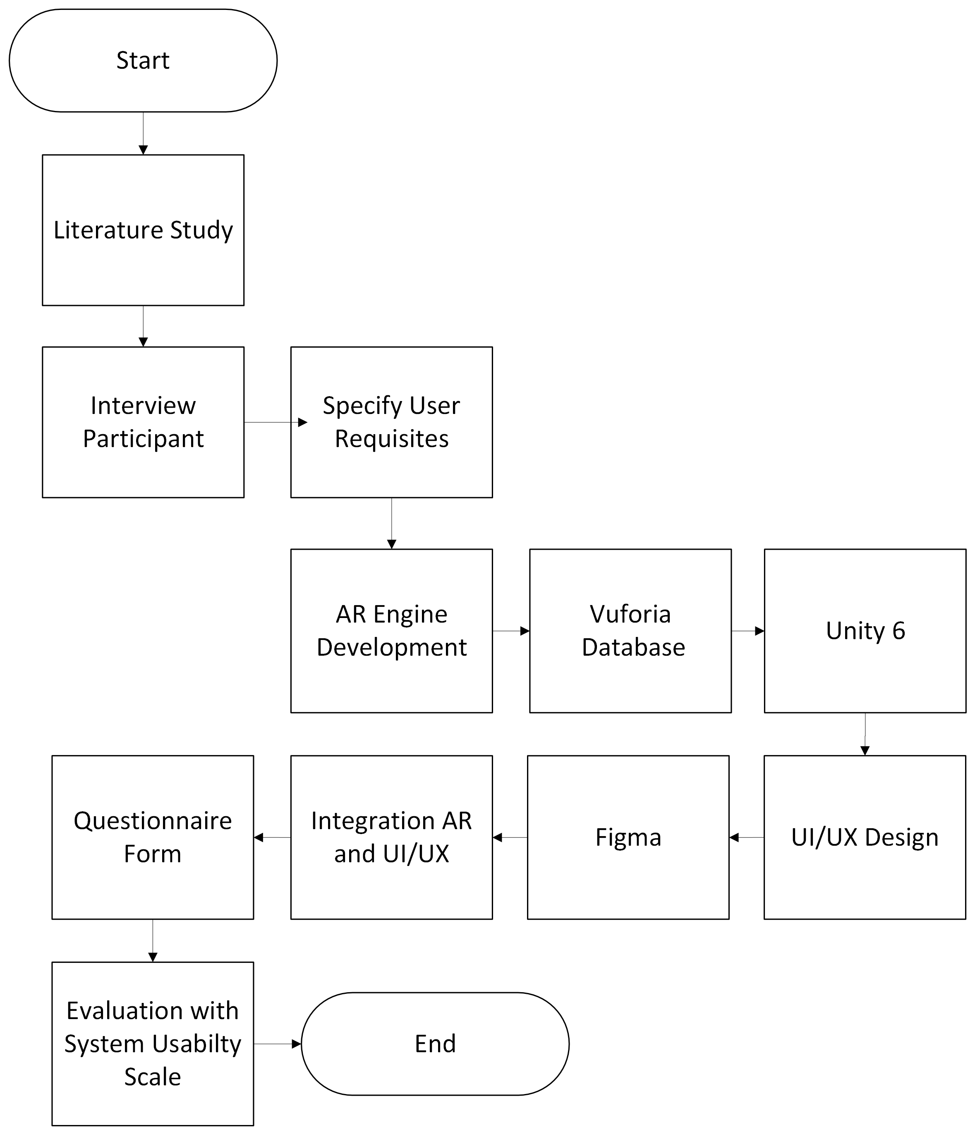

## The Integration of Augmented Reality and User-Centered Design (UCD) in Programming Education

The integration of augmented reality (AR) and user-centered design (UCD) has been shown to facilitate programming theory, rendering it more interactive and easier to understand [5]. A substantial body of research has demonstrated the considerable promise inherent in integrating these two approaches. However, the majority of existing applications are confined to rudimentary visual elements, failing to leverage the comprehensive interactive potential of AR [14]. These limitations result in suboptimal learning experiences in the context of complex programming. Integration of AR and UCD has been implemented to create a more effective, adaptive, and user-centered learning environment.

Figure 1. Flowchart of Research Phase

# Research Method

## Data Collection

This research employs a qualitative methodology, integrating interviews and questionnaires to gather insights from students at SMK 1 Jakarta and students at Bina Sarana Informatika University. Participants in the study ranged in age from 17 to 20 years, represent a key demographic transitioning from adolescence to young adulthood, enabling a deeper understanding of their learning needs. In addition to primary data, secondary data was collected through literature reviews. This secondary data was used to support the theoretical framework and to provide information in the design process. As a result, a comprehensive foundation was established for the development of an augmented reality Augmented Reality (AR) based educational application.

## Research Phase

This research went through the steps in the research flowchart, starting with interviews with participants to get insights into user needs, and ending with an evaluation stage. The initial stage included identifying problems and analyzing user needs, followed by creating an Augmented Reality (AR) application prototype using the Vuforia Database for AR Card recognition and Unity for tracking 3D objects on AR Cards. The UI/UX design of this application was created using Figma, applying User-Centered Design (UCD) principles to ensure an intuitive interface that meets user needs. Evaluation was conducted by collecting data through questionnaires filled out by participants, measuring the success of the application using the System Usability Scale (SUS). As illustrated in Figure 1, the overall research process demonstrates the sequential relationship between stages, from planning to final evaluation.

This methodological framework facilitates the development of an application that is not only technically effective but also aligns with user expectations in the context of Python programming learning using AR.

## System Architecture

The Augmented Reality (AR) application system for Python programming education was constructed using an AR engine that integrates various essential modules, including image processing, 3D projection, and user interaction. As illustrated by the system architecture diagram in , the workflow and interactions between components in the application are delineated, thereby elucidating the contributions of each module to the provision of an interactive and immersive learning experience. The AR engine is responsible for real-time processing of user input, which is integrated with 3D visualization to facilitate understanding of programming concepts. This system architecture guarantees seamless interaction and an effective visual presentation, thereby facilitating the learning process.

Figure 2. Diagram System of Augmented Reality

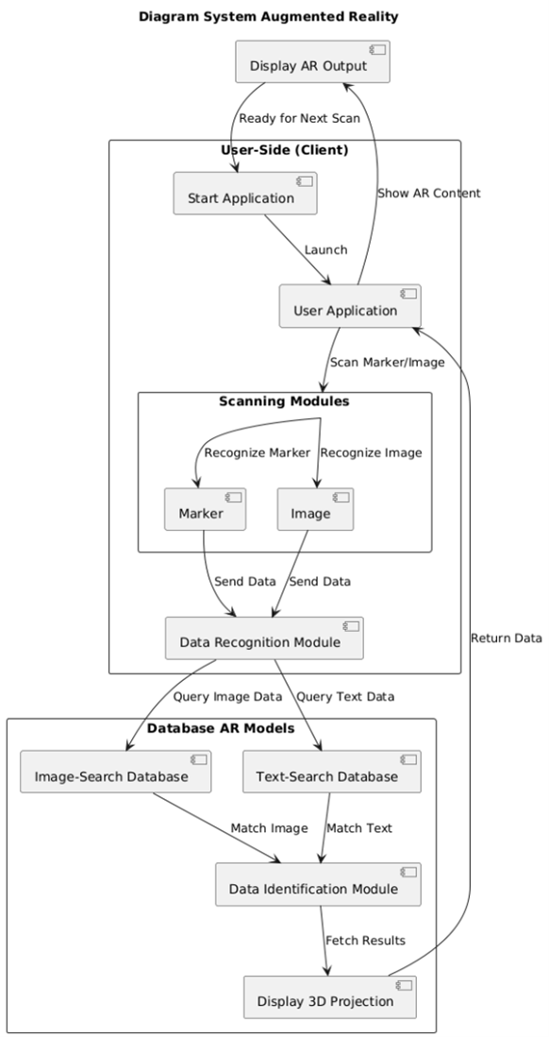

## User-Centered Design (UCD)

User-Centered Design (UCD) is an approach to application development that prioritizes user needs and expectations, with the objective of creating intuitive and effective solutions. The UCD procedure is comprised of the following steps:

1. Understand Context of Use: The objective of this stage is to comprehend the context of application use, encompassing the manner and rationale behind user utilization of the Augmented Reality (AR) application for Python learning, as well as the application's efficacy in this particular context.
2. Specify User Requirements: In this stage, data regarding the end users' needs is collected. Such needs may include the required features, the desired usage methods, and the desired level of comfort in interacting with the AR application.
3. Design Solutions: In accordance with an understanding of the context and user needs, design solutions are developed to create an intuitive user interface, taking into account important aspects such as interactivity and accessibility for users.
4. Evaluate against Requirements: The evaluation stage entails the collection of user feedback, employing the System Usability Scale (SUS) to assess the extent to which the application meets user expectations and needs.

## System Usabilty Scale (SUS)

The System Usability Scale (SUS) is a widely used method for evaluating the usability of a system. It was introduced by John Brooke in 1986. Table I, which is composed of 10 questions, delineates each question from the questionnaire. The questionnaire contains 5 positive questions and 5 negative questions, which encompass various aspects of user experience and ease of use.

TABLE I. QUESTIONNAIRE OF SYSTEM USABILITY SCALE

|  |  |
| --- | --- |
| **No** | **System Usability Scale Questions** |
| 1 | “*Saya merasa mudah belajar pemrograman Python menggunakan aplikasi ARPY*.”  I find it easy to learn Python programming using the ARPY app. |
| 2 | “Saya merasa aplikasi ARPY sulit untuk digunakan”  I find the ARPY application difficult to use. |
| 3 | “Saya tertarik belajar pemrograman dengan metode visual/interaktif yang disediakan oleh ARPY.”  I am interested in learning programming using the visual/interactive method provided by ARPY. |
| 4 | “Saya merasa fitur yang disediakan oleh aplikasi ARPY tidak cukup membantu dalam belajar pemrograman.”  I feel that the features provided by the ARPY app are not helpful enough for learning programming. |
| 5 | “Fitur interaktif dalam aplikasi ini sangat membantu saya dalam memahami materi.”  The interactive features in this app are very helpful in understanding the material. |
| 6 | “Pembelajaran dengan menggunakan ARPY lebih membingungkan dibandingkan dengan metode tradisional seperti buku atau video.”  Learning with ARPY is more confusing than traditional methods such as books or videos. |
| 7 | “Saya merasa lebih mudah memahami konsep abstrak Python ketika menggunakan tampilan visual 3D dalam ARPY.”  I find it easier to understand abstract Python concepts when using the 3D visual display in ARPY. |
| 8 | “Saya merasa aplikasi ARPY tidak cukup menarik untuk terus digunakan dalam jangka panjang.”  I feel that the ARPY application is not interesting enough to continue using in the long term. |
| 9 | “Saya akan merekomendasikan aplikasi ARPY kepada teman jika aplikasi ini membantu dalam memahami Python.”  I would recommend the ARPY app to my friends if it helps them understand Python. |
| 10 | “Saya merasa aplikasi ARPY membutuhkan bantuan teknis yang sering untuk digunakan dengan efektif.”  I feel that the ARPY application requires frequent technical assistance to be used effectively. |

The respondents are asked to rate the system using a Likert scale, with Table II detailing the ratings for each question on a scale of 1 to 5. The resulting scores are then calculated to provide a final usability score.

TABLE II. QUESTIONNAIRE SCORE RANGE

|  |  |
| --- | --- |
| Answer | Score |
| Sangat Setuju (SS) | 5 |
| Setuju (S) | 4 |
| Netral (N) | 3 |
| Tidak Setuju (TS) | 2 |
| Sangat Tidak Setuju (STS) | 1 |

The System Usability Scale formula is as follows:

**Score R** = ((Q1-1)+(5-Q2)+(Q3-1)+(5-Q4)+(Q5-1)+(5-Q6)+(Q7-1)+(5-Q8)+(Q9-1)+(5-Q10))×2,5

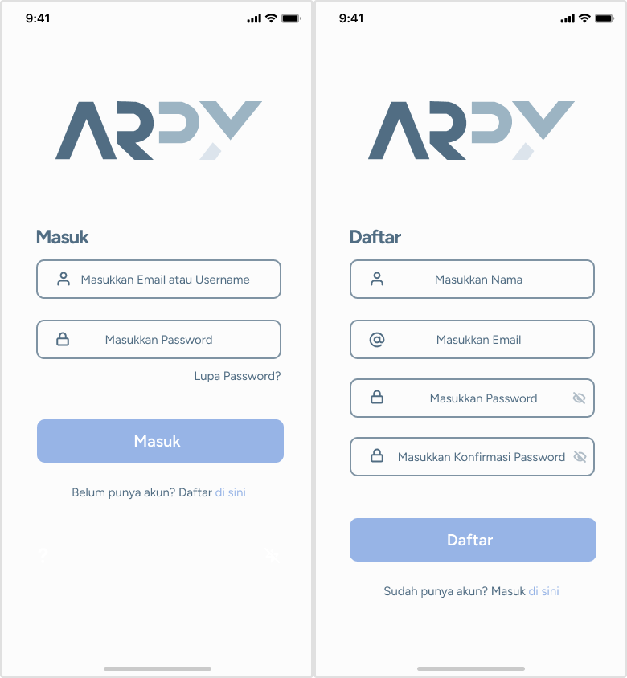

Fig. 3. Login and Register Page of Augmented Reality Python

Where Q1…Q10 represent the scores obtained for each question from the respondents. The SUS score, when converted using the provided formula, is ranged from 0 to 100. The resulting value indicates the extent to which the system is accepted and used efficiently by its users.

# Results and Discussions

The results of this study used the User-Centered Design (UCD) method with two main procedures, namely Understand Context of Use and Specify User Requirements, which underlie the development of an Augmented Reality (AR) application for Python learning.

## Understand Context of Use

The research explored the context of use for the AR application by engaging students from vocational and higher education. Through interviews, students shared their interest in using augmented reality (AR) for Python programming, particularly its interactive features and the ability to visualize abstract concepts like data structures and logic through 3D objects. They emphasized the need for a more engaging, visually enhanced learning environment to improve understanding of challenging programming topics. The integration of AR in the classroom was seen as an exciting and effective way to deepen comprehension of programming concepts.

## Specify User Requirements

User requirements for the AR application were gathered through interviews and categorized into key features. Students highlighted the need for a structured learning path with step-by-step guidance through Python concepts. They favored interactive features allowing manipulation of 3D objects with immediate feedback and the ability to click on objects for additional context. Quizzes, mini-projects, and practical exercises were seen as essential for reinforcing learning. Motivational elements like certifications and badges were valued to encourage engagement. Accessibility was also a priority, with students wanting the app to be free and available across multiple devices, ensuring inclusivity for all users. These insights were used to guide the design and development of the AR application, aligning it with users' needs to enhance their learning experience.

## Design Solution

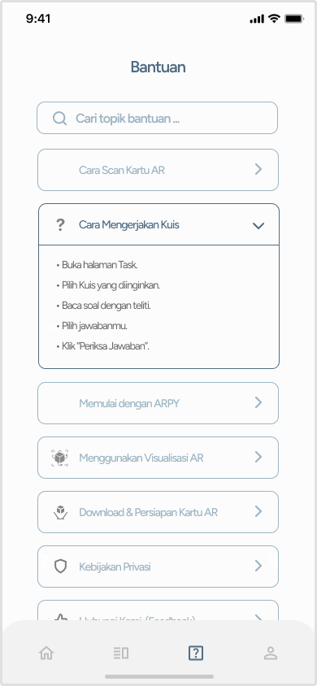

This research resulted in an application design solution that focuses on the User-Centered Design (UCD) approach in the ARPY application, covering several main pages with clear and intuitive visual displays for users.

The design of the Login and Register page Figure 3 is characterized by its simplicity and effectiveness. It implements input forms with clear icons, thereby enhancing the user experience and facilitating the process of accessing and registering accounts. The page's design prioritizes ease of navigation, featuring clear main buttons that facilitate a swift login and registration process, devoid of significant obstacles.

Fig. 3. Login and Register Page of Augmented Reality Python

The Home and Task page designs Figure 4 feature a user interface designed to provide easy access to interactive learning materials in the form of quizzes and projects. This display offers direct navigation with an appealing and informative visual design, enabling users to immediately perceive their learning progress, accompanied by illustrative content that enhances the learning experience.

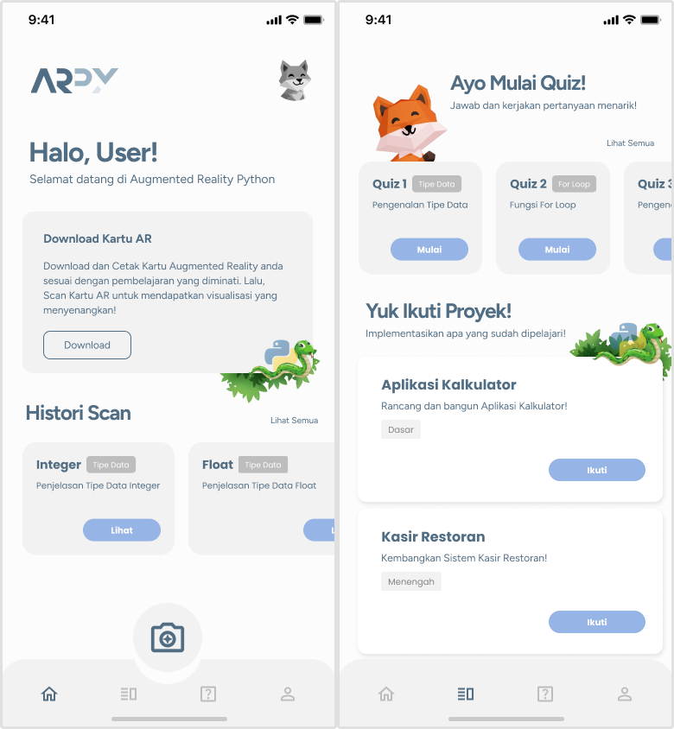

Fig. 4. Home and Task Page of Augmented Reality Python

The Guide page Figure 5 is designed with user-friendliness in mind, making it easy for users to find help or instructions on how to use the application. Elements such as a search bar for help topics, clear dropdown menus, and easy-to-follow step-by-step instructions make this page intuitive and effective in providing guidance to new users.

Fig. 5 Guide Page of Augmented Reality Python

The Profile and Edit Profile page designs Figure 6 facilitate the management of personal information for users. The layout is uncomplicated and straightforward, featuring icons and input fields that are readily identifiable, thereby enabling users to efficiently and expeditiously modify their profile data. This feature fosters personalization of the application.  
Fig 6. Profile and Edit Profile Page of Augmented Reality Python

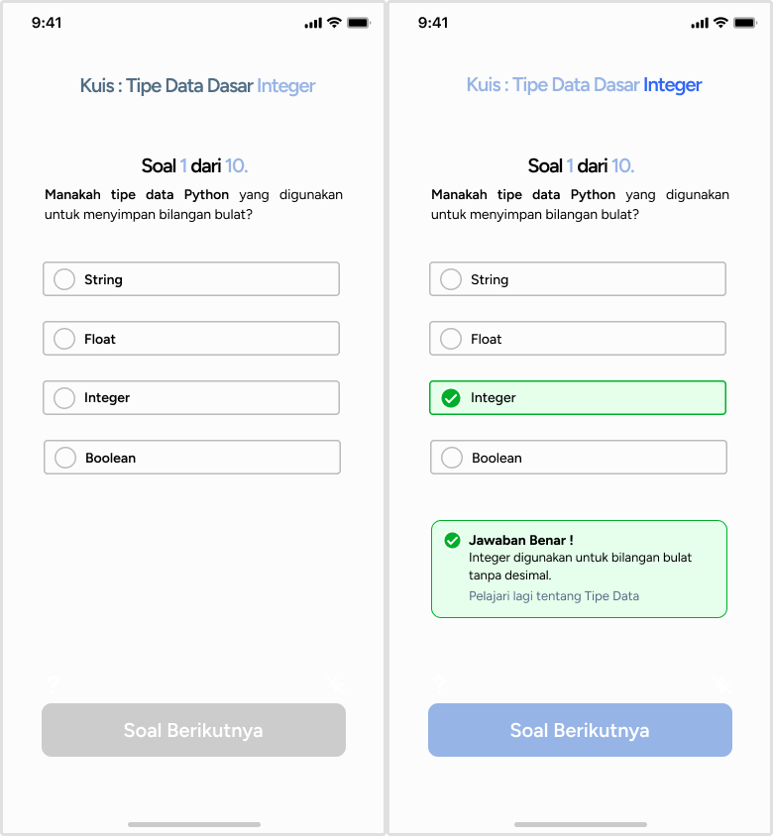

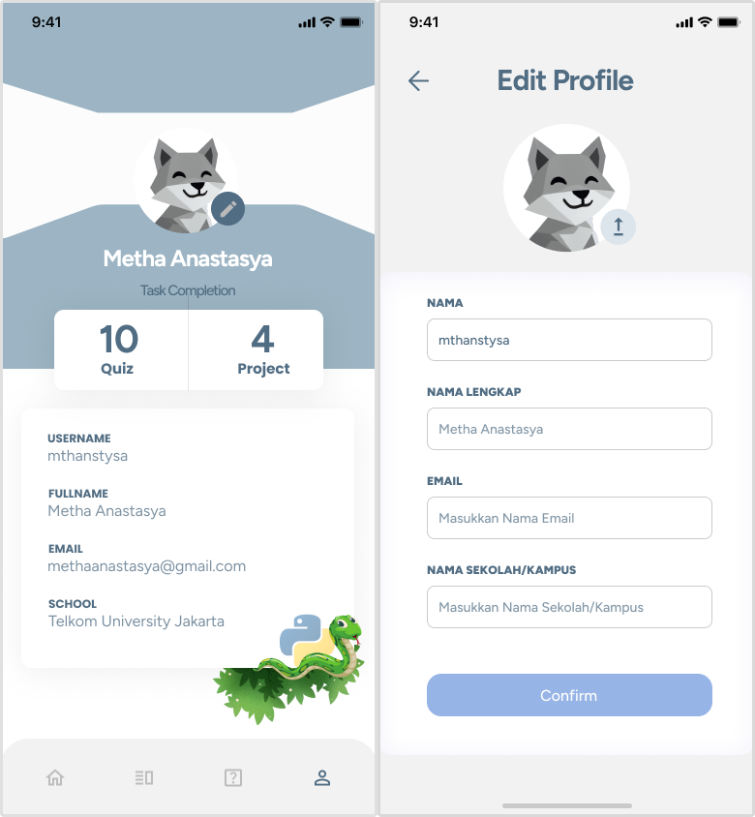

The AR Scan, AR Result, and Result Detail Page Figure 7, are characterized by simplicity and intuitiveness, facilitating the scanning of AR cards and the subsequent display of augmented reality visualizations. The Result page presents three-dimensional (3D) visualizations that users can rotate, accompanied by concise information regarding the scanned object. The Detail Result page offers a thorough elucidation of the selected learning concept, accompanied by concise Python code illustrations and interactive buttons that facilitate access to supplementary AR visualizations or direct users to relevant quizzes. This multifaceted approach enables users to consolidate their comprehension in a systematic manner.

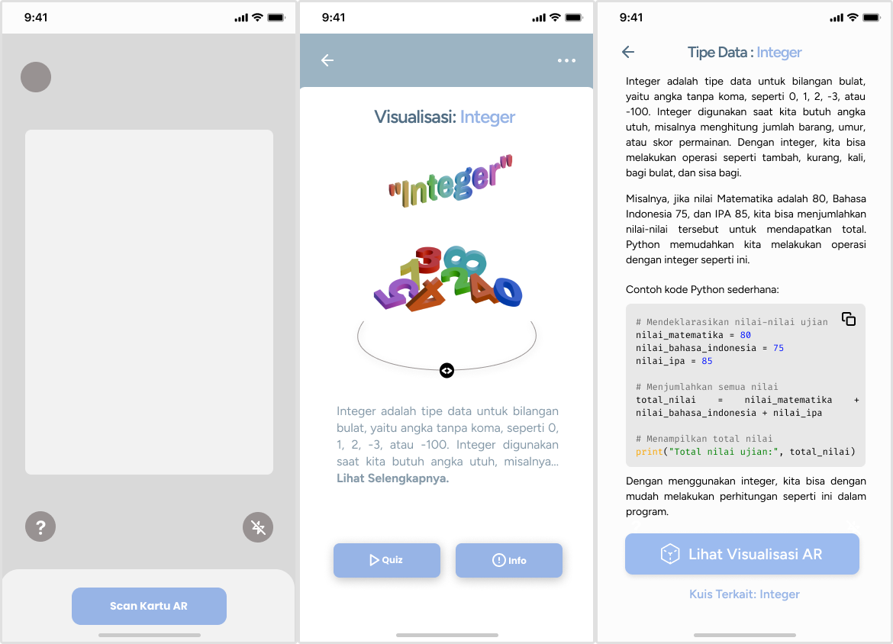

Fig 7. AR Scan, AR Result, and Result Detail Page of Augmented Reality Python

The design of Quiz Page Figure 8 employs a minimalist approach, emphasizing ease of user interaction when working on quiz questions. The Quiz Page presents inquiries with four distinct and readily identifiable answer options. In the event of an accurate response by the user, the response is indicated by a green highlight, accompanied by a confirmation message, a concise explanation of the response, and an optional link providing access to further material on the subject. This approach is meticulously designed to guarantee that users not only ascertain the correct response but also discern the underlying rationale, thereby amplifying the efficacy of the learning process through the application.

Fig 8. Quiz Page of Augmented Reality Python

## Evaluate Against Requirements

The data for evaluating the System Usability Scale (SUS) were obtained from questionnaires completed by 30 participants. Table III contains information about the participants who were assigned to evaluate the application using a 10-item scale, ranging from 1 (strongly disagree) to 5 (strongly agree). These scores were then used to calculate the total SUS score, which assesses the ease of use of the ARPY (Augmented Reality Python) application. The collective responses of the participants were used to comprehensively evaluate the system, providing a comprehensive overview of user interaction with the application and their perceptions of its usefulness.

TABLE III. SCORE OF SYSTEM USABILITY SCALE ARPY

|  |  |  |  |  |  |  |  |  |  |  |  |
| --- | --- | --- | --- | --- | --- | --- | --- | --- | --- | --- | --- |
| No | Q1 | Q2 | Q3 | Q4 | Q5 | Q6 | Q7 | Q8 | Q9 | Q10 | Score R |
| 1 | 5 | 2 | 5 | 2 | 5 | 2 | 5 | 2 | 5 | 2 | 87,5 |
| 2 | 5 | 1 | 5 | 5 | 5 | 5 | 5 | 5 | 5 | 5 | 60 |
| 3 | 4 | 3 | 4 | 2 | 5 | 1 | 5 | 3 | 4 | 3 | 75 |
| 4 | 5 | 2 | 4 | 1 | 5 | 1 | 5 | 1 | 4 | 1 | 92,5 |
| 5 | 4 | 3 | 4 | 2 | 3 | 2 | 3 | 3 | 4 | 3 | 62,5 |
| 6 | 4 | 4 | 5 | 3 | 4 | 3 | 4 | 4 | 5 | 4 | 60 |
| 7 | 5 | 5 | 4 | 2 | 4 | 2 | 4 | 4 | 5 | 5 | 60 |
| 8 | 5 | 5 | 5 | 2 | 4 | 2 | 4 | 2 | 4 | 4 | 67,5 |
| 9 | 5 | 4 | 5 | 3 | 4 | 3 | 4 | 4 | 5 | 4 | 62,5 |
| 10 | 3 | 3 | 3 | 3 | 3 | 3 | 4 | 2 | 5 | 3 | 60 |
| 11 | 3 | 2 | 5 | 3 | 4 | 2 | 5 | 3 | 4 | 4 | 67,5 |
| 12 | 5 | 2 | 5 | 1 | 5 | 3 | 5 | 2 | 5 | 5 | 80 |
| 13 | 3 | 4 | 5 | 5 | 5 | 4 | 4 | 2 | 5 | 5 | 55 |
| 14 | 5 | 5 | 5 | 4 | 5 | 5 | 5 | 3 | 4 | 2 | 62,5 |
| 15 | 5 | 3 | 5 | 3 | 5 | 3 | 5 | 3 | 5 | 3 | 75 |
| 16 | 5 | 1 | 5 | 5 | 5 | 1 | 5 | 1 | 5 | 1 | 90 |
| 17 | 4 | 2 | 5 | 2 | 4 | 2 | 4 | 2 | 5 | 4 | 75 |
| 18 | 5 | 2 | 5 | 2 | 4 | 2 | 4 | 2 | 4 | 3 | 77,5 |
| 19 | 4 | 3 | 4 | 2 | 4 | 2 | 4 | 2 | 4 | 4 | 67,5 |
| 20 | 5 | 3 | 4 | 3 | 5 | 3 | 5 | 3 | 5 | 3 | 72,5 |
| 21 | 3 | 2 | 5 | 2 | 4 | 3 | 4 | 2 | 4 | 3 | 70 |
| 22 | 3 | 2 | 3 | 2 | 3 | 3 | 3 | 2 | 5 | 3 | 62,5 |
| 23 | 4 | 2 | 4 | 2 | 4 | 2 | 4 | 2 | 4 | 4 | 70 |
| 24 | 3 | 3 | 3 | 2 | 3 | 2 | 4 | 3 | 4 | 4 | 57,5 |
| 25 | 4 | 2 | 4 | 2 | 4 | 2 | 4 | 2 | 5 | 3 | 75 |
| 26 | 4 | 3 | 4 | 2 | 4 | 2 | 4 | 2 | 4 | 4 | 67,5 |
| 27 | 5 | 1 | 5 | 1 | 5 | 2 | 5 | 1 | 5 | 2 | 95 |
| 28 | 3 | 3 | 4 | 3 | 4 | 2 | 3 | 3 | 4 | 3 | 60 |
| 29 | 3 | 3 | 4 | 2 | 4 | 3 | 3 | 2 | 5 | 5 | 60 |
| 30 | 4 | 2 | 4 | 2 | 4 | 2 | 5 | 2 | 5 | 2 | 80 |
| **Score Of System Usability Scale ARPY** | | | | | | | | | | | **70,25** |

The System Usability Scale (SUS) for ARPY was calculated based on the responses to the questionnaire, yielding a score of 70.25. The individual scores for each of the 30 participants were aggregated, and the weighted average of these scores was subsequently computed. The total score is indicative of the overall usability rating of the ARPY application. It provides insights into the extent to which the application meets the needs of its users with regard to ease of use, functionality, and user satisfaction.

System Usability Scale score threshold is generally regarded as 68, with scores above 68 indicating acceptable usability and those below 68 suggesting potential usability issues as shown in Figure 8. Given that the SUS score for ARPY is 70.25, it surpasses the established threshold, thereby signifying that the application demonstrates commendable user-friendliness and aligns with prevailing usability expectations.

Fig. 8 System Usability Scale Scoring

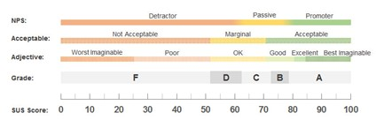

# Conclussion

In conclusion, the research successfully demonstrated that the integration of Augmented Reality (AR) with the User-Centered Design (UCD) approach significantly enhances the learning experience of Python programming. By incorporating AR technology, abstract programming concepts like data structures and branching logic were presented in a more interactive and visually engaging manner, making them easier for students to understand. The application, ARPY, developed through this study, meets the identified user requirements and achieves a satisfactory usability score of 70.25, indicating its effectiveness in terms of user-friendliness and engagement. Future work should focus on expanding the complexity of the learning content in ARPY and testing its application in diverse educational settings. Additionally, further research could explore the long-term impact of AR-based learning on programming skills and student retention rates.

##### References

[1] D. Djusmalinar and F. D. Mukti, “The Urgency of Technology-Based Education for Primary School in Indonesia,” *WANIAMBEY: Journal of Islamic Education*, vol. 3, no. 1, pp. 12–23, Jun. 2022, doi: 10.53387/waniambey.v3i1.434.

[2] H. Hadiyanto, F. Failasofah, A. Armiwati, M. Abrar, and Y. Thabran, “Students’ Practices of 21st Century Skills between Conventional learning and Blended Learning,” Jambi, Jul. 2021. doi: 10.53761/1.18.3.7.

[3] A. Yahya Saleh, G. Suk Chin, M. Kamal Othman, F. Suraya Mohamad, and C. Jen Chen, “Immersive Visualization of Python Coding Using Virtual Reality,” *International Journal of Advanced Science, Engineering and Information Technology*, vol. 13, no. 1, pp. 336–347, 2023, doi: 10.18517/ijaseit.13.1.16028.

[4] T. Srimadhaven, A. V. Chris Junni, N. Harshith, S. Jessenth Ebenezer, S. Shabari Girish, and M. Priyaadharshini, “Learning analytics: Virtual reality for programming course in higher education,” in *Procedia Computer Science*, Elsevier B.V., May 2020, pp. 433–437. doi: 10.1016/j.procs.2020.05.095.

[5] V. T. Nguyen, K. Jung, and T. Dang, “BlocklyAR: A visual programming interface for creating augmented reality experiences,” *Electronics (Switzerland)*, vol. 9, no. 8, pp. 1–20, Aug. 2020, doi: 10.3390/electronics9081205.

[6] A. Theodoropoulos and G. Lepouras, “Augmented Reality and programming education: A systematic review,” Dec. 01, 2021, *Elsevier B.V.* doi: 10.1016/j.ijcci.2021.100335.

[7] P. Subhashini, R. Siddiqua, A. Keerthana, and P. Pavani, “Augmented Reality in Education,” *Journal of Information Technology and Digital World*, vol. 02, no. 4, pp. 221–227, Dec. 2020, doi: 10.36548/jitdw.2020.4.006.

[8] E. Ivarson, V. Erlandsson, M. Faraon, and S. Khatib, “Augmented reality and gamification in higher education: Designing mobile interaction to enhance students’ motivation and learning,” *E-Learning and Digital Media*, pp. 1–20, Mar. 2024, doi: 10.1177/20427530241239981.

[9] M. Kiourexidou, A. Kanavos, M. Klouvidaki, and N. Antonopoulos, “Exploring the Role of User Experience and Interface Design Communication in Augmented Reality for Education,” *Multimodal Technologies and Interaction*, vol. 8, no. 6, Jun. 2024, doi: 10.3390/mti8060043.

[10] P. Prameswari, R. Mai Candra, M. Affandes, and L. Oktavia, “Desain UI/UX Aplikasi Manajemen Keuangan Pribadi Menggunakan Metode User Centered Design (UCD),” *Jurnal Pendidikan dan Teknologi Indonesia*, vol. 5, no. 1, Jan. 2025, doi: 10.52436/1.jpti.567.

[11] C. Y. Tsai and Y. C. Lai, “Design and Validation of an Augmented Reality Teaching System for Primary Logic Programming Education,” *Sensors*, vol. 22, no. 1, Jan. 2022, doi: 10.3390/s22010389.

[12] A. M. Al-Ansi, M. Jaboob, A. Garad, and A. Al-Ansi, “Analyzing augmented reality (AR) and virtual reality (VR) recent development in education,” May 10, 2023, *Elsevier Ltd*. doi: 10.1016/j.ssaho.2023.100532.

[13] A. A. Ilham, “Design of Python Programming Learning Media Interaction Design Using the UCD Method,” *Indonesian Journal of Social Technology*, vol. 5, no. 12, pp. 5631–5646, Dec. 2024, doi: 10.59141/jist.v5i12.1334.

[14] S. Alif, P. Nasution, H. Wulandari, and R. Dwi Arista, “Perancangan UI/UX Aplikasi Moblie Pertolongan Pertama Dengan Metode Prototipe Interaksi Untuk Meningkatkan Respon Darurat,” *Media Online)*, vol. 5, no. 1, pp. 14–23, Dec. 2024, doi: 10.47065/bulletincsr.v5i1.432.